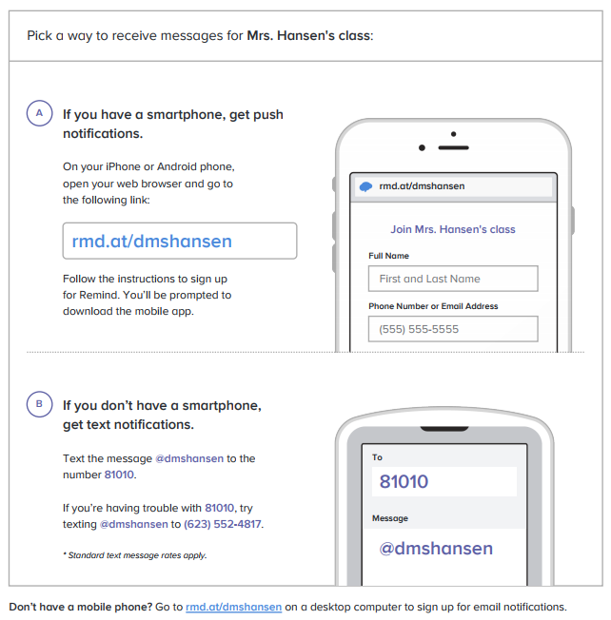

**Earn 2 points of Extra Credit when you sign up for Mrs. Hansen’s Reminds!**

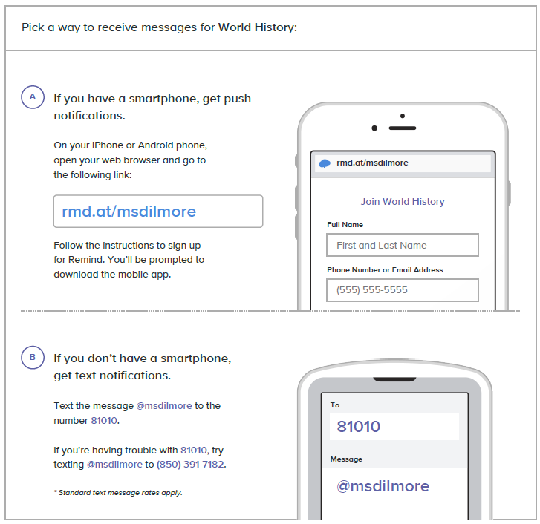

**Earn 2 points of Extra Credit when you sign up for Mrs. Hansens’s Reminds!**